1.LOGIN SCREEN

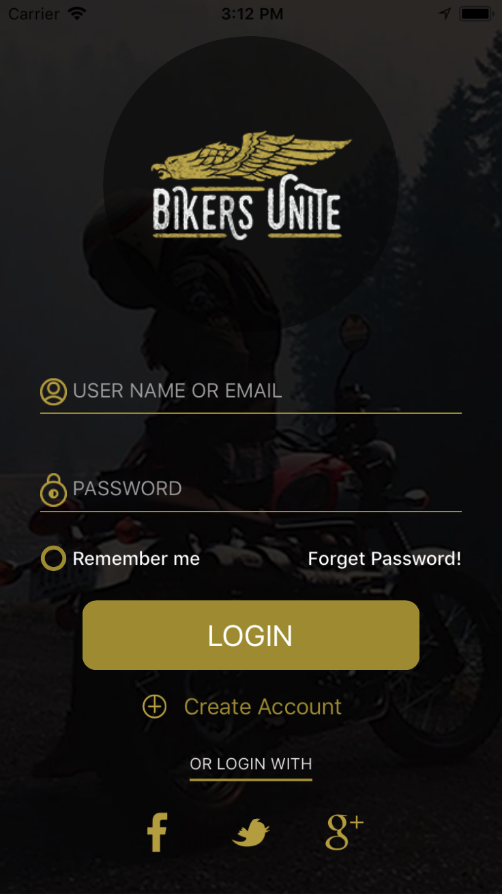

CLASS– LoginViewController

This screen is for login to the Application, User can login to Application using Facebook, Twitter and Google,

For Facebook, Google and Twitter We are using Pod

Remember me option is to remember the username while logging In, By Clicking on create Account User can register him self.

2.FORGOT PASSWORD SCREEN

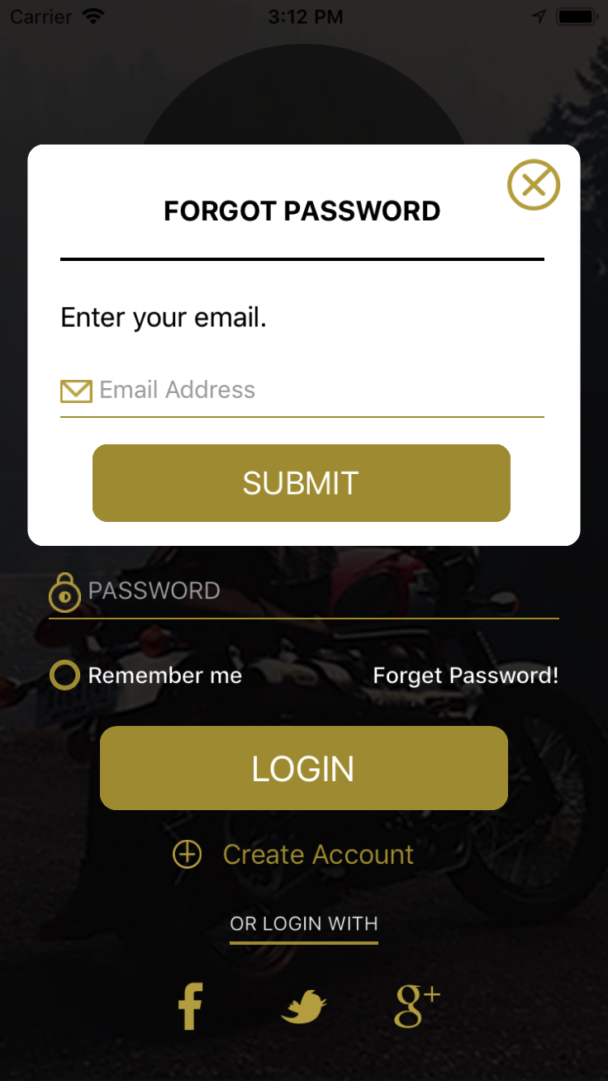

CLASS– ForgotPasswordViewController

The Forgot Password dialog box will open when user click on Forgot Password Link from Login Screen.

User Can enter the email in pop up,Dynamically Generated password will be sent to Email Address provided by user.

3.REGISTRATION SCREEN

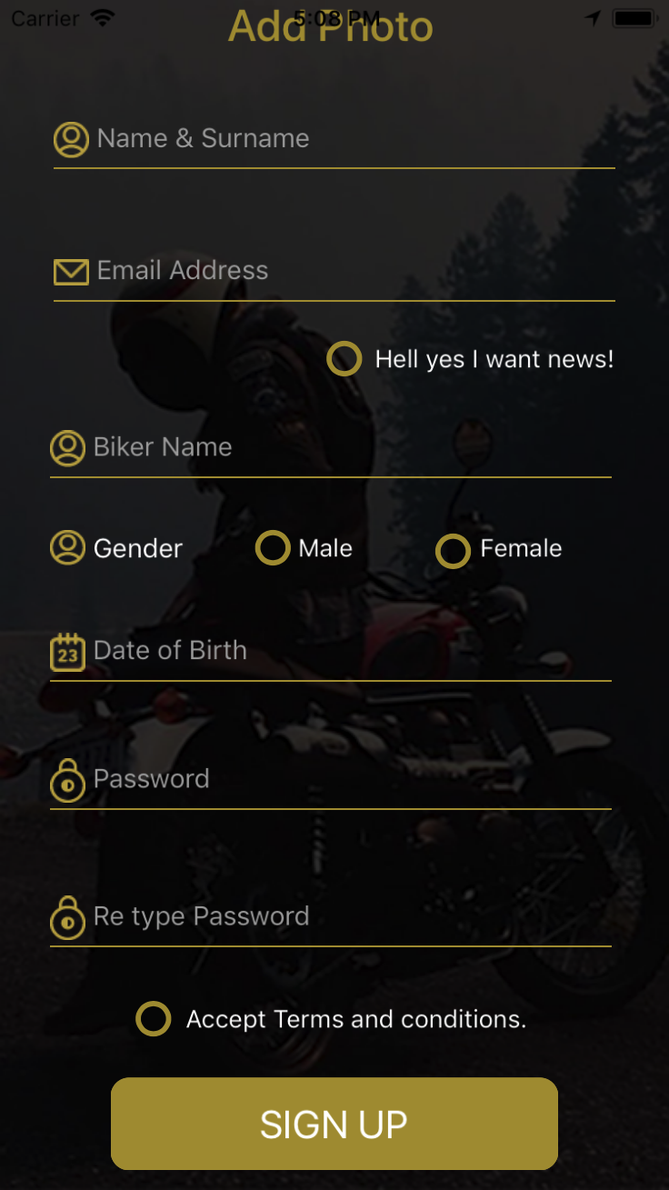

CLASS– RegisterViewController

This screen Can be user for Registerig to the Application

When user Register through facebook , Twitter and Google

Some of the Information will be prefilled like Email, Name

User can enter rest of the Information.

4. TERMS AND CONDITION

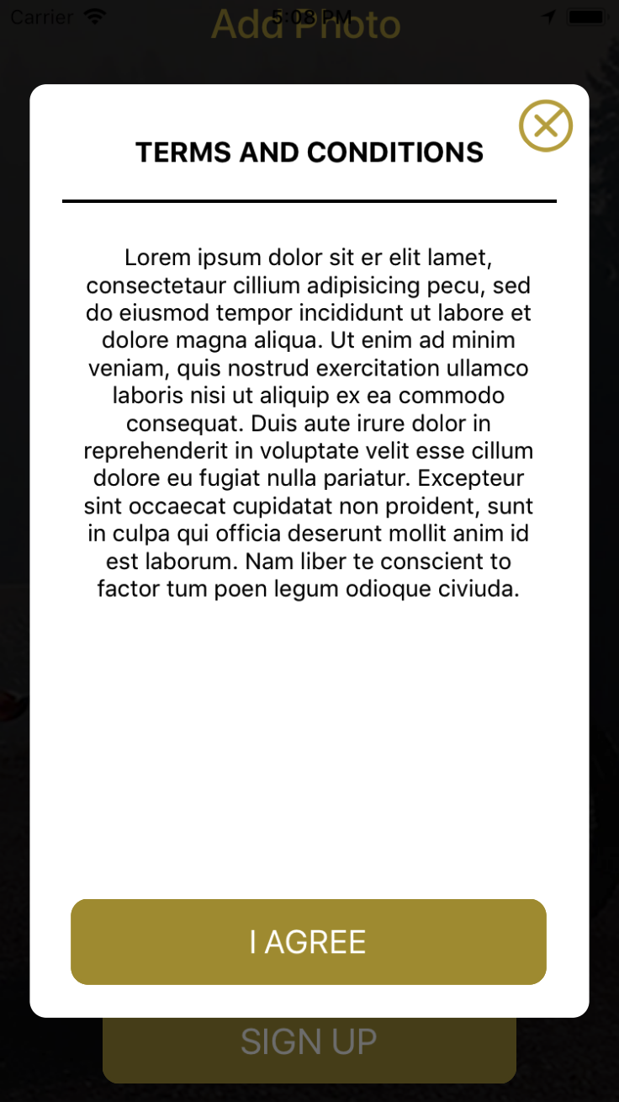

CLASS– TermsAndConditionsViewController

User need to check the terms and condition option in registration screen before registering.

5. SPLASH SCREEN

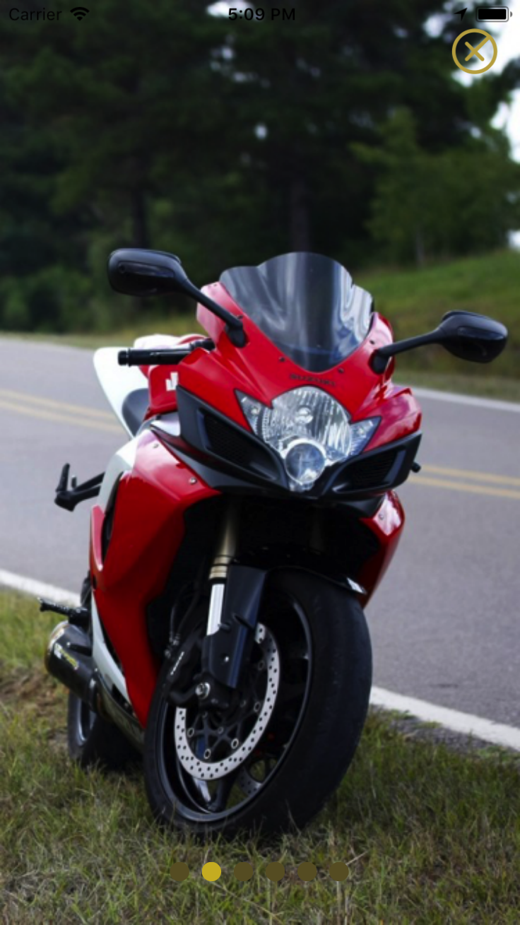

CLASS– SliderPagesViewController

Splash screen will open after login to application and whenever user launch the Application.

6. DASHBOARD SCREEN

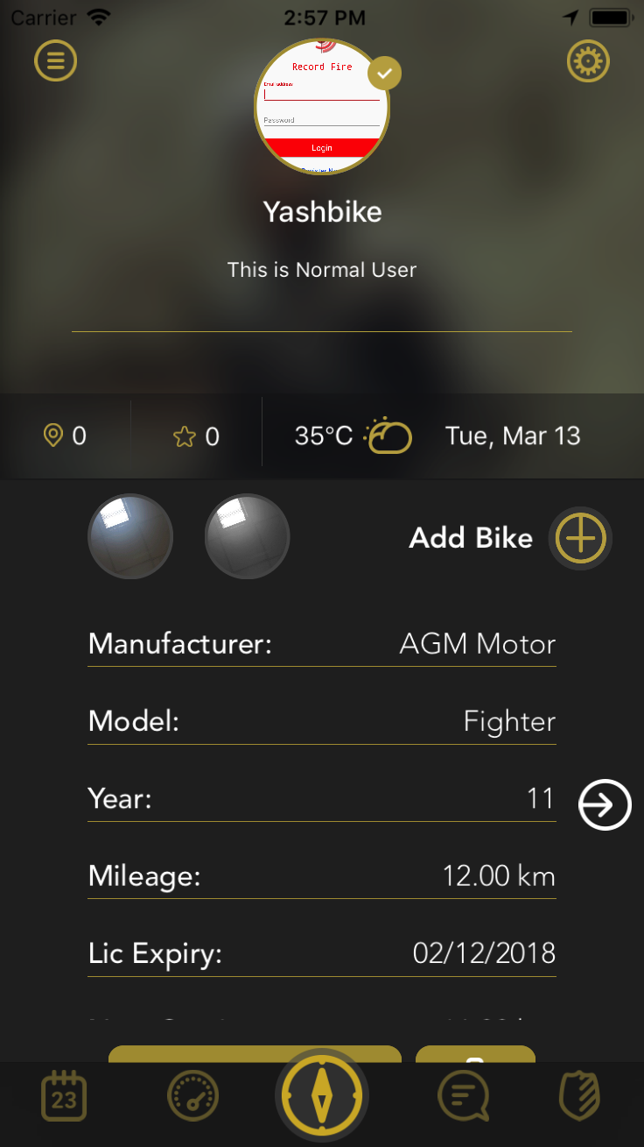

CLASS– MainViewController

The screen displays the detail of all the bike user have added, Clicking on add bike user can add bike.

User can EDIT the added bike information by clicking on the Edit button below similarly, for deleting bike deatil user can click on delete button.

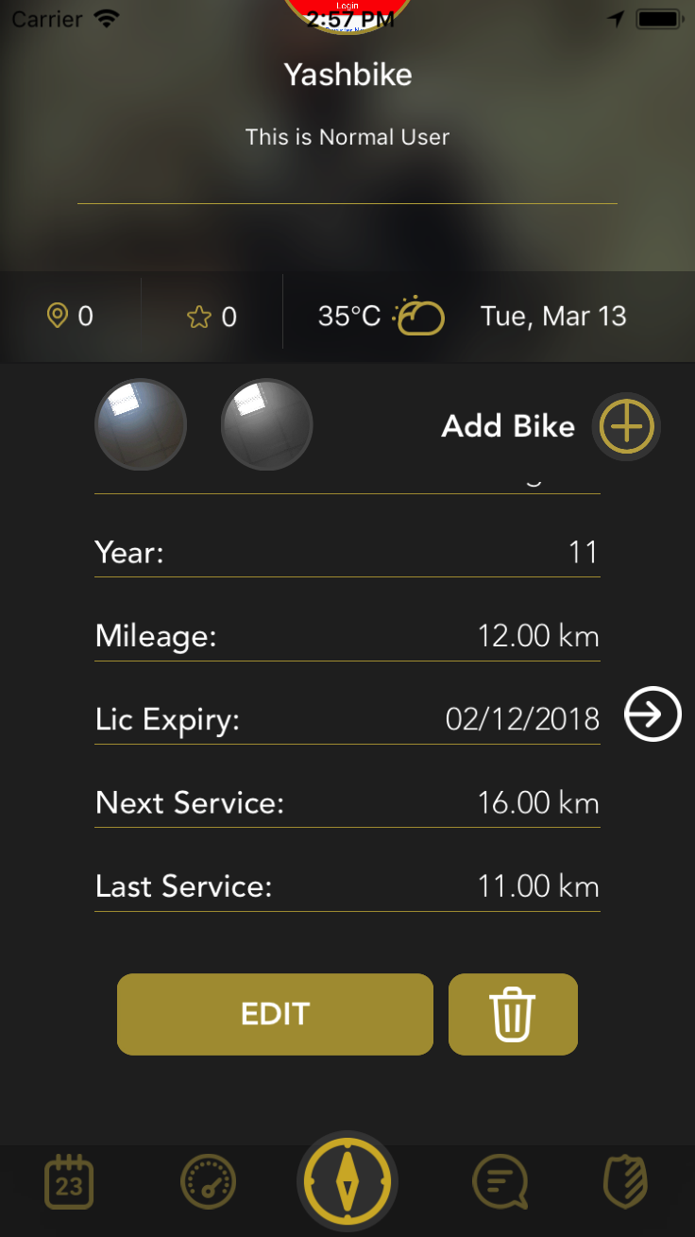

7. EDIT BIKE DETAIL SCREEN

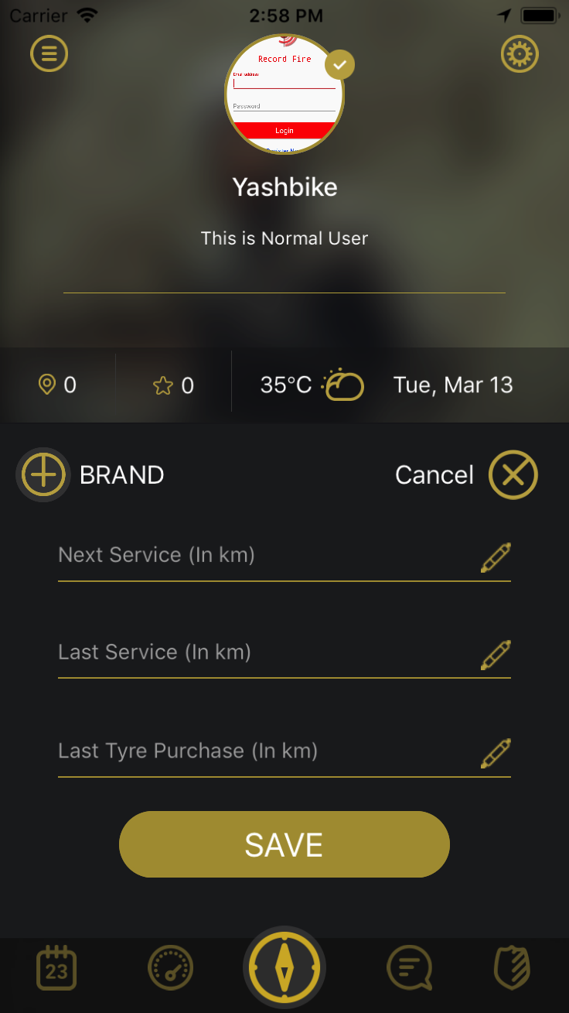

CLASS – AddBikeDetailViewController

This Screen adds and updates the bike details

For adding Manufacture an model details user can select from popup.

WEATHER SCREEN

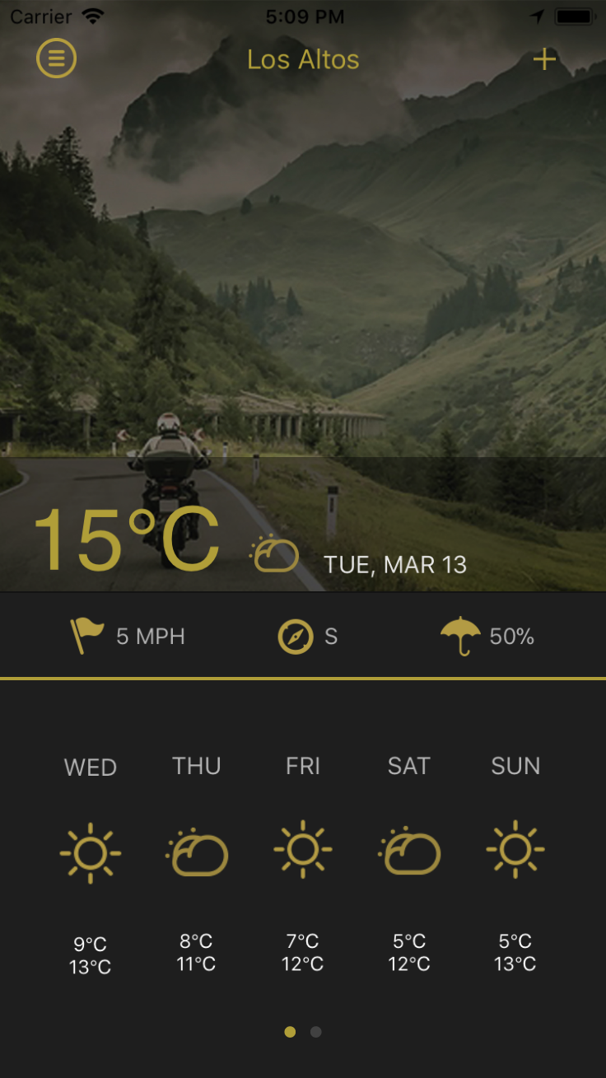

CLASS – WeatherViewController

Weather screen displays the weather Information of current Place by default

We have used dark Sky API and SwiftSky pod

For auto search places feature we have used mapbox search places API

We are using our internal chetu account for dark sky API

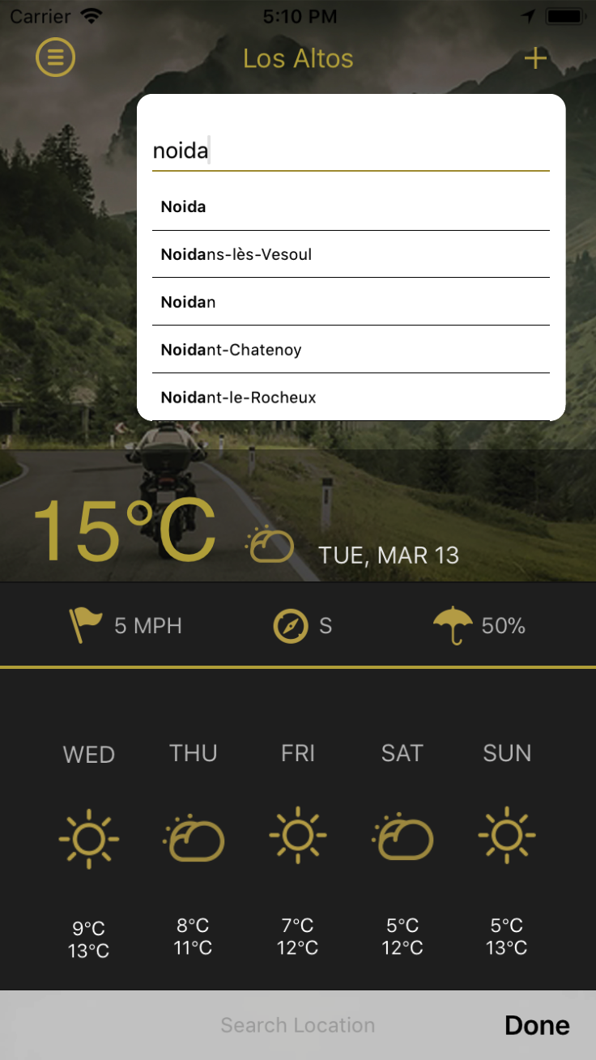

8. MENU SCREEN

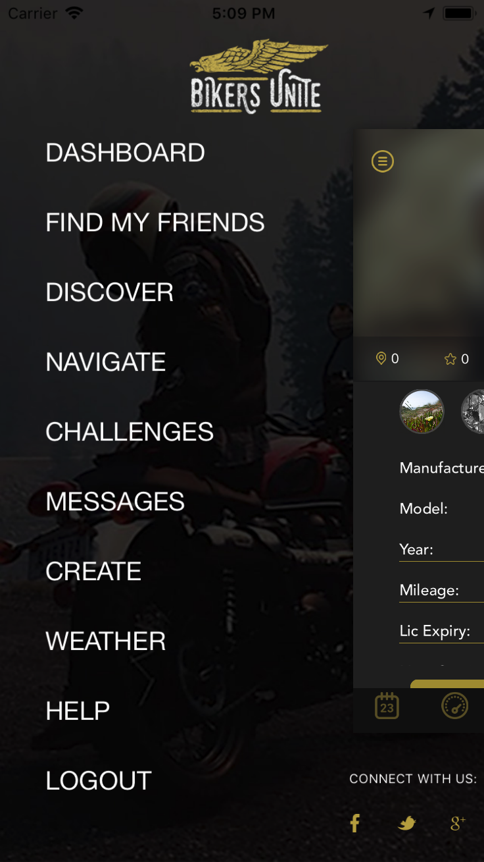

CLASS – LeftMenuViewController

This screen can be used for navigating to other screens

8. PROFILE SCREEN

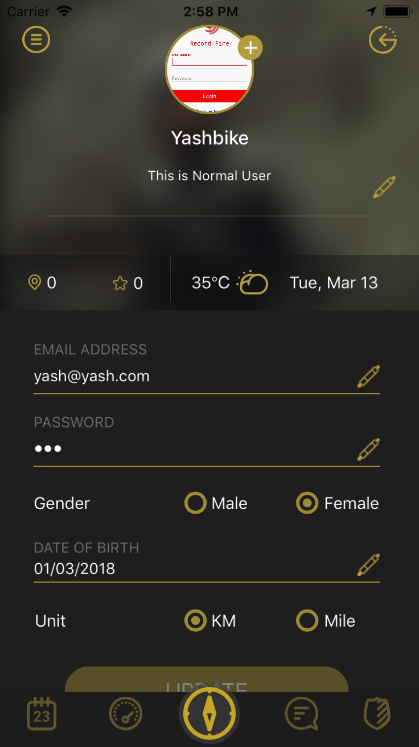

CLASS – UserProfileViewController

User can update profile information from this screen

User can update unit from here it will get reflection in bike detail screen.

App can be shared in Facebook, Twitter, Google by clicking on below share options

We have used pod for sharing on Facebook and Twitter and Google Share API for sharing in Google.

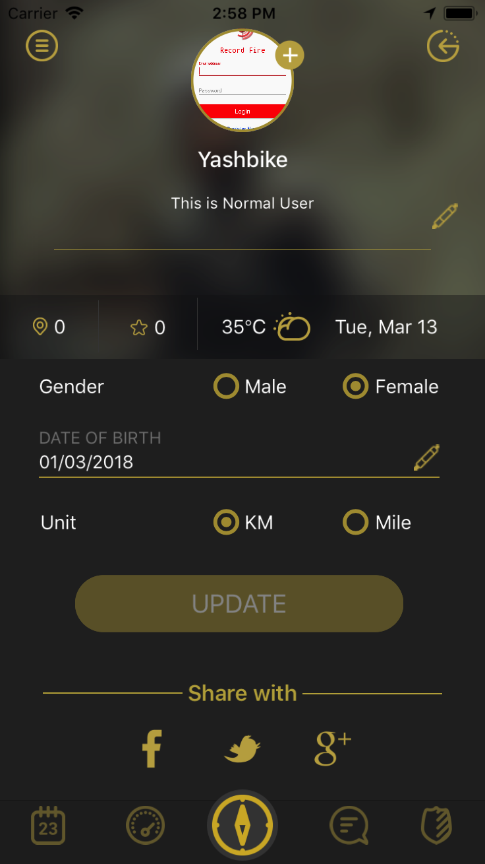

8. CHANGE PASSWORD SCREEN

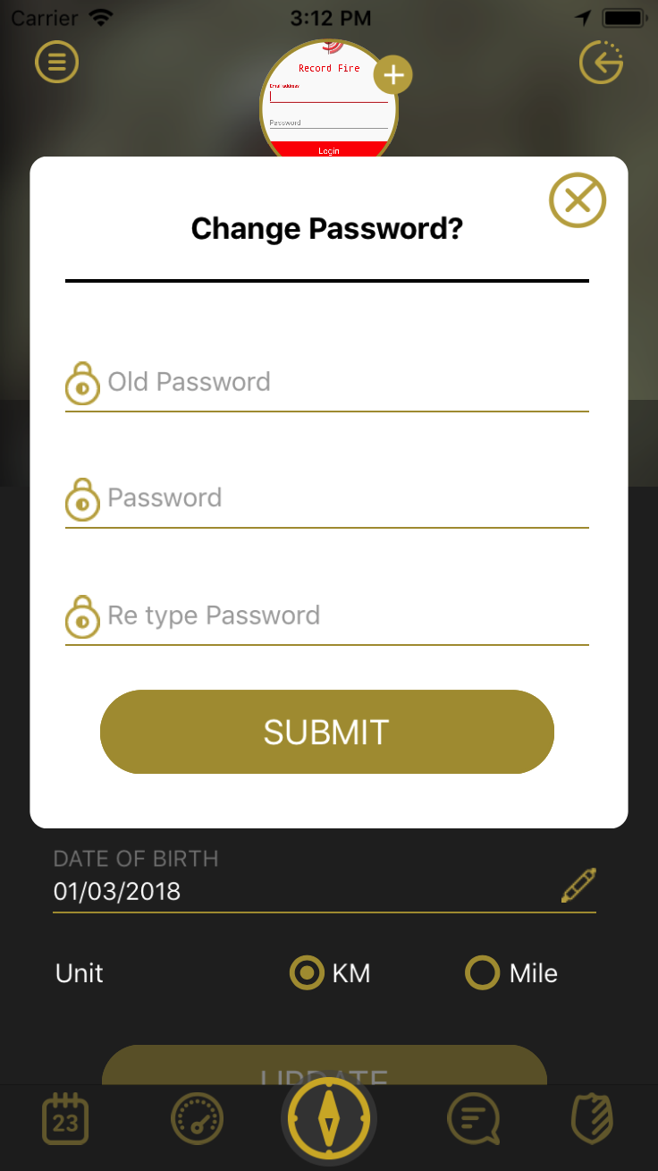

CLASS – UserProfileViewController

User can change the password from this dialog box by entering old password, password and new password.

8. DISCOVER SCREEN

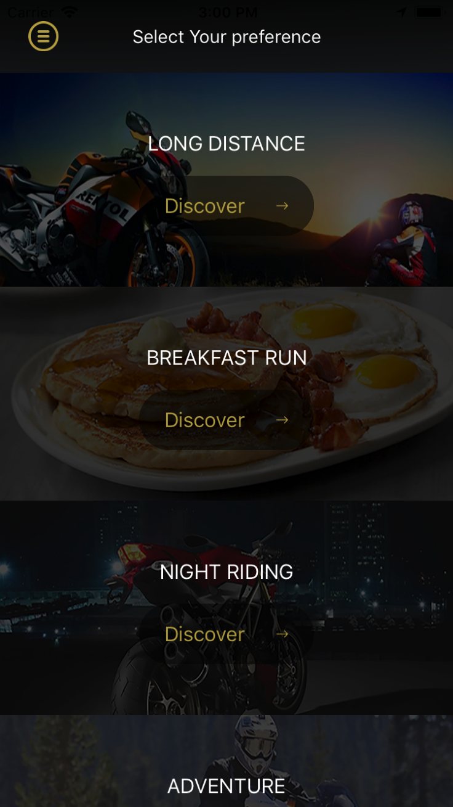

CLASS – DiscoverMainViewController

Discover screen contains six categories clicking on categories user can see listing of near by venues or dealers.

8. VENUES DISPLAY SCREEN

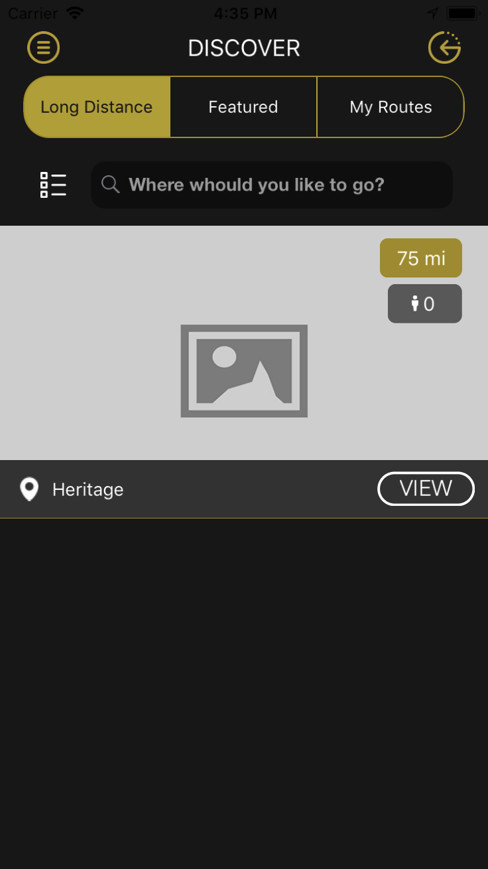

CLASS – VenueViewController

This Screen displays the list of venues near to user, User can see featured venue under the category by clicking on feature option at the top.

8. VENUES DETAIL SCREEN

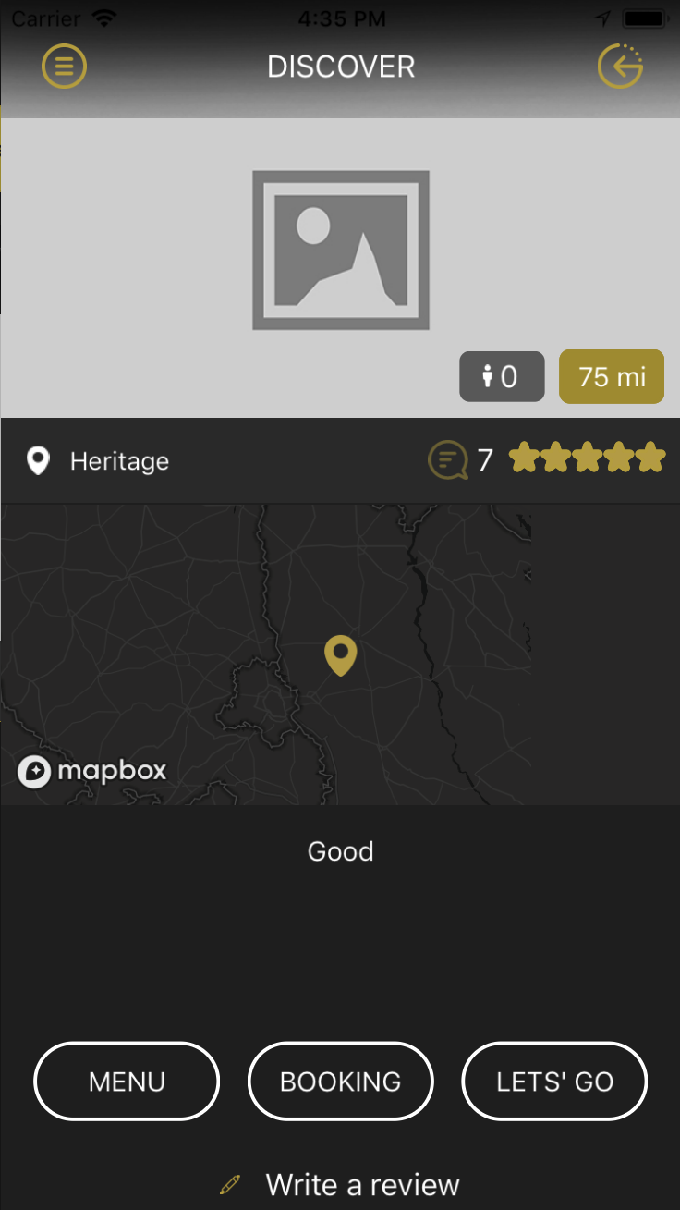

CLASS – VenueDetailViewController

This Screen displays the detail of selected venue.

User can see menus, Book a venue, write review and can navigate to particular venue location by clicking on lets’Go option.

For map we have user Mapbox.

8. VENUES BOOKING SCREEN

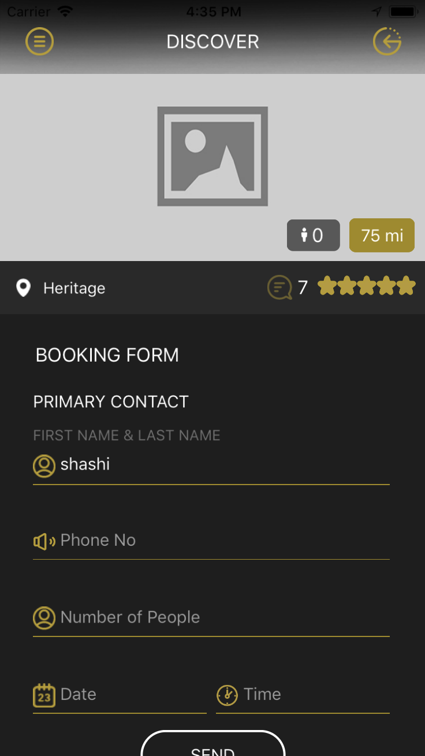

CLASS – VenueBookingViewController

This Screen Books the Venue for logged in user.

8. VENUES DETAIL SCREEN

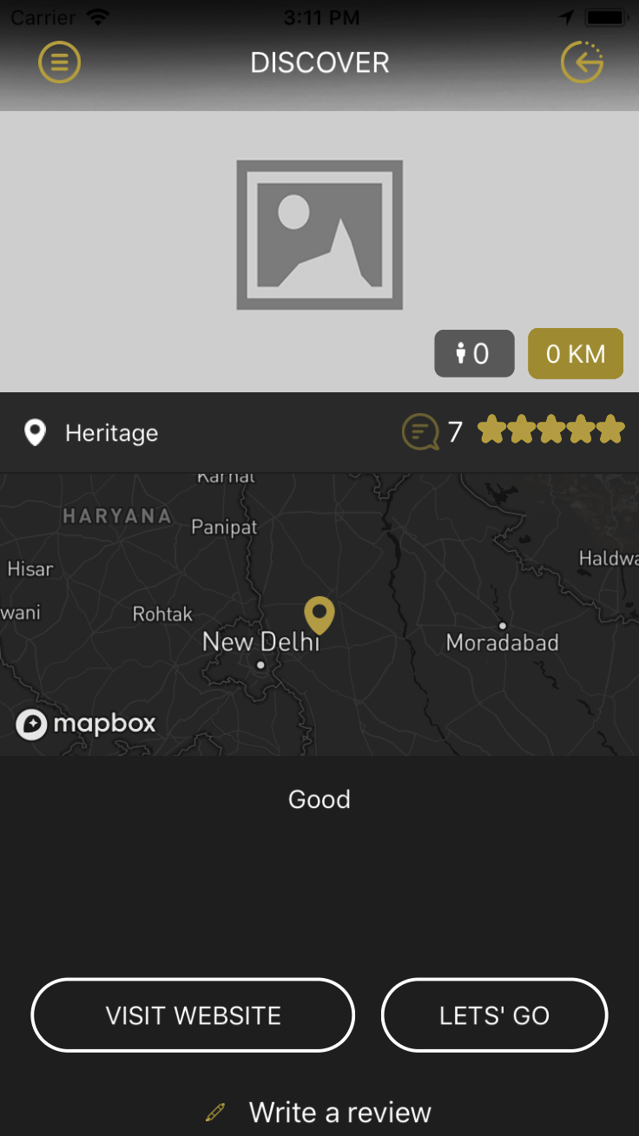

CLASS – VenueDetailViewController

This Screen displays the detail of selected venue.

The screen will open when user click on Accessories(category)from discover screen.

Here user can visit website.

8. MY ROUTE SCREEN

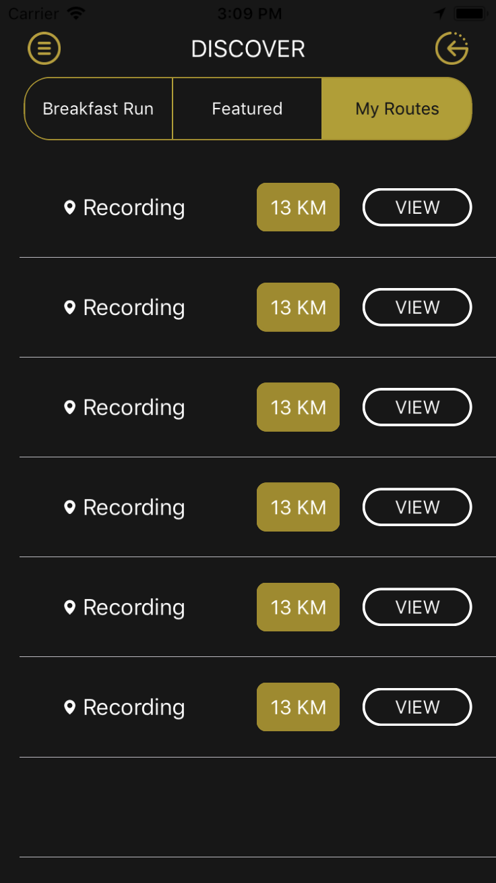

CLASS – RouteViewController

This Screen will display the saved routes.

8. VENUE SORT POP UP

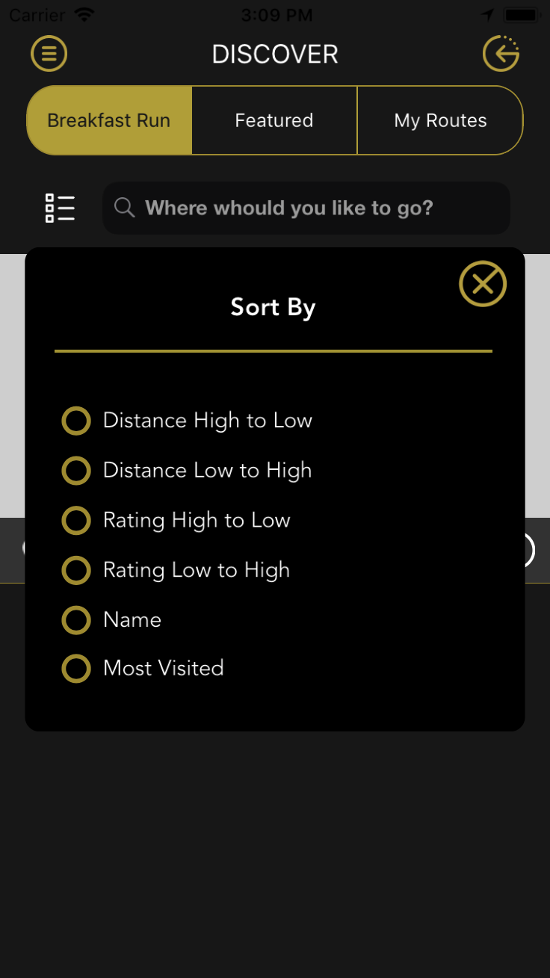

CLASS – VenueSortingViewController

This Pop will appear by clicking on sort icon in venue List Screen.

Can be used to sort the venues based on selected parameter.

8. REVIEW LIST SCREEN

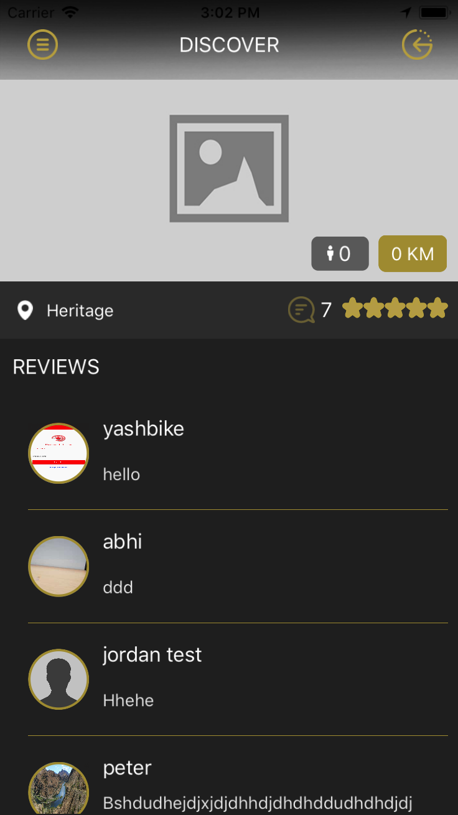

CLASS – ReviewListViewController

This screen will appear by clicking on top message icon.

Here user can see all the reviews given by users on particular venue.

8. REVIEW SCREEN

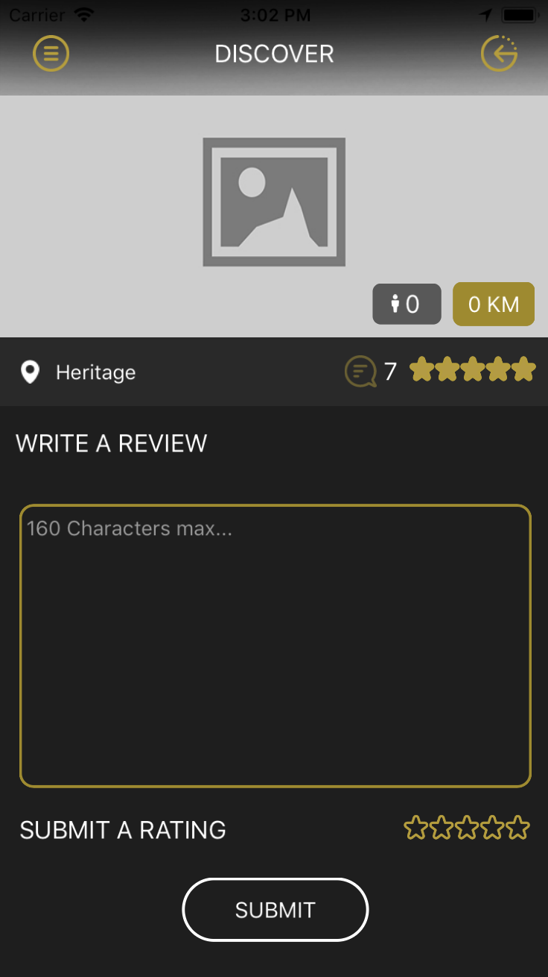

CLASS – VenueReviewViewController

Review screen will appear when user click on write review option from venue detail screen. This screen is used to provide reviews on particular venue.

8. MENU SCREEN

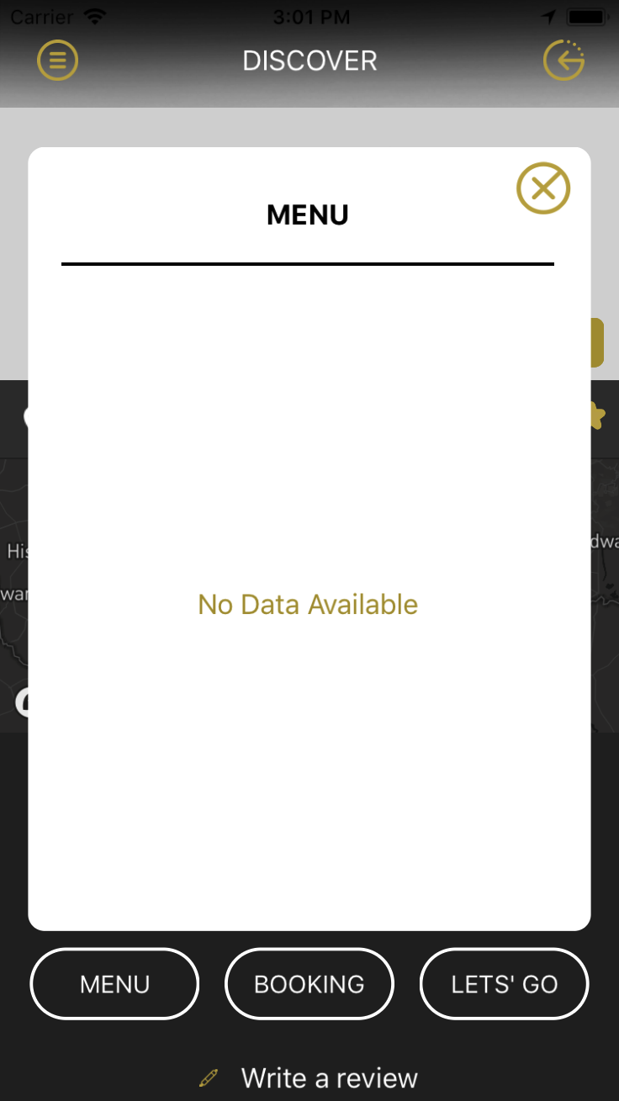

CLASS – MenuViewController

Menu screen will appear when user click on menu option from venue detail screen. This screen displays menu’s

8. FIND MY FRIEND SCREEN

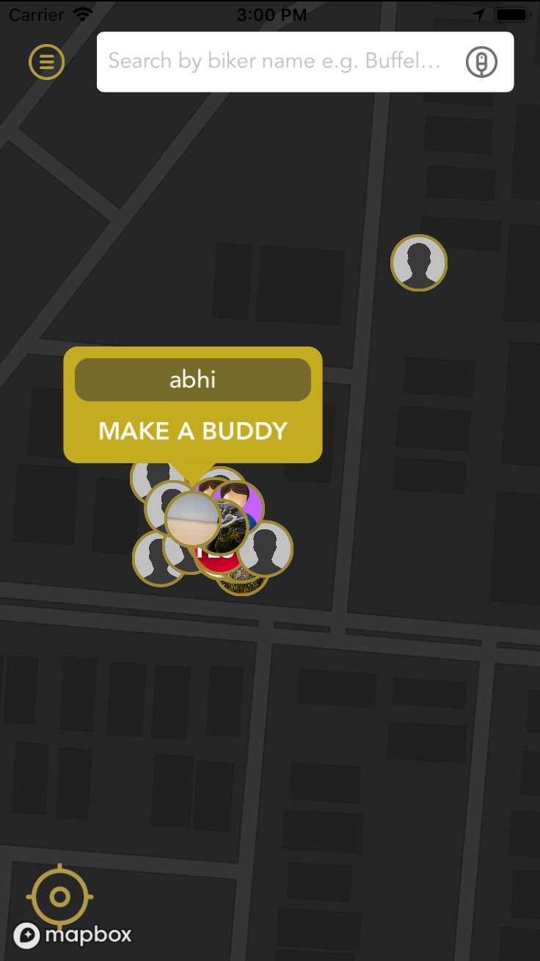

CLASS – FindAFriendViewController

Find MY friend screen displays near by users

User can search near by user using friend name.

Here we have implemented mapbox.

8. NAVIGATION SCREEN

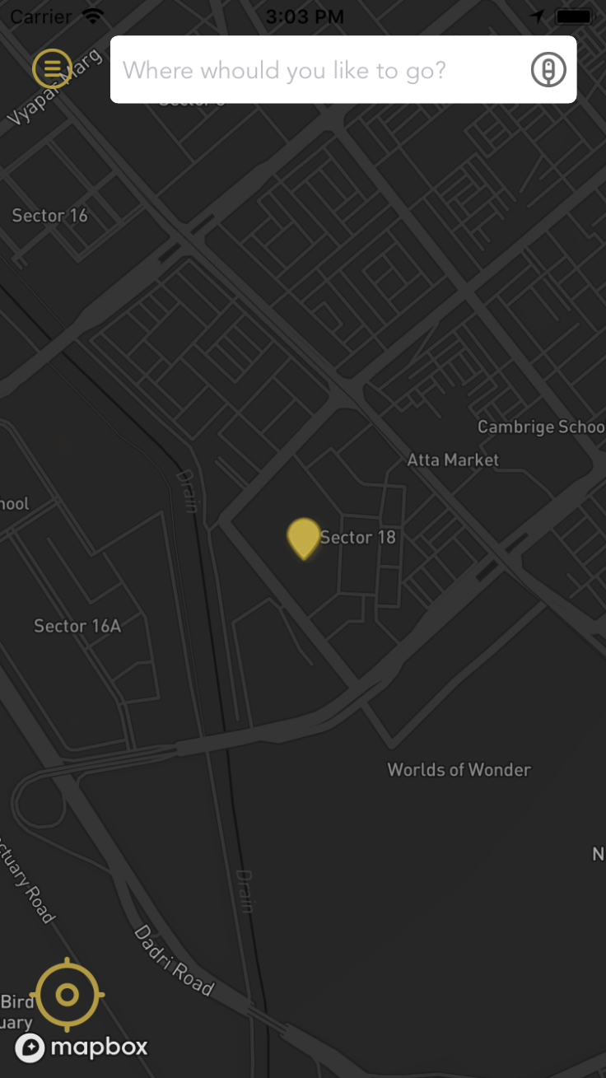

CLASS – NavigationGViewController

Navigation screen is used to navigate to particular location, User can search the location from top search bar

We have used mapbox places API for displaying places and mapbox matrix API for showing distances.

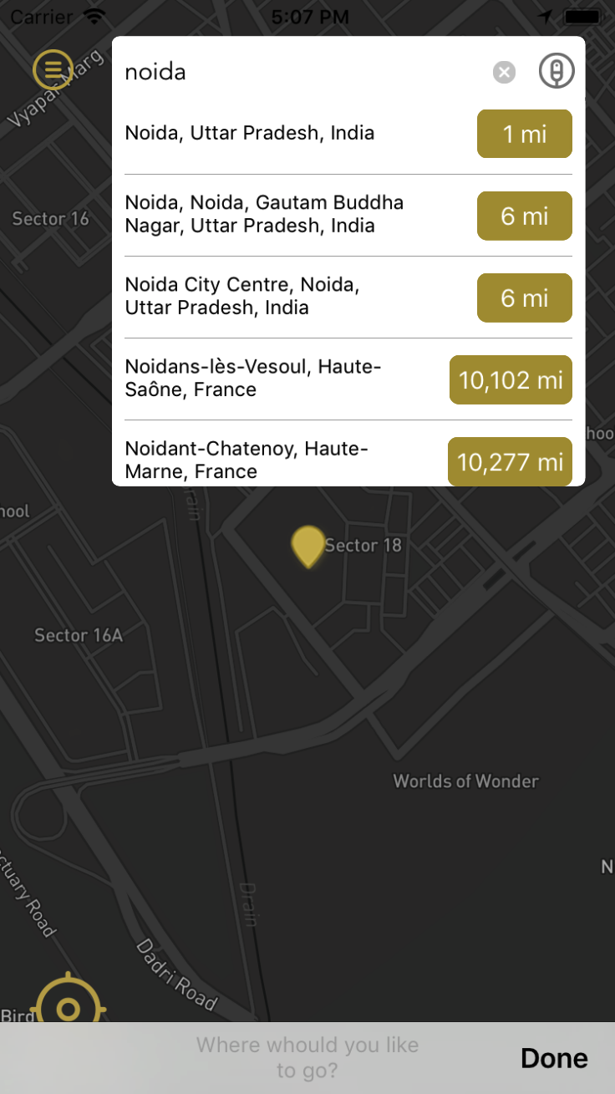

8. ETA POP UP

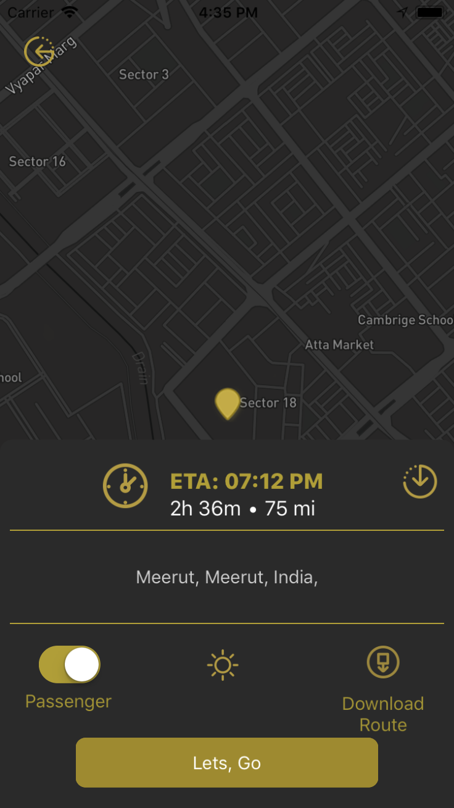

CLASS – ETADetailsViewController

The POP up will appear after selecting a particular location from search places list, It displays Information such as ETA, Arrival Time, duration, Destination Address and weather detail.

8. ETA POP UP

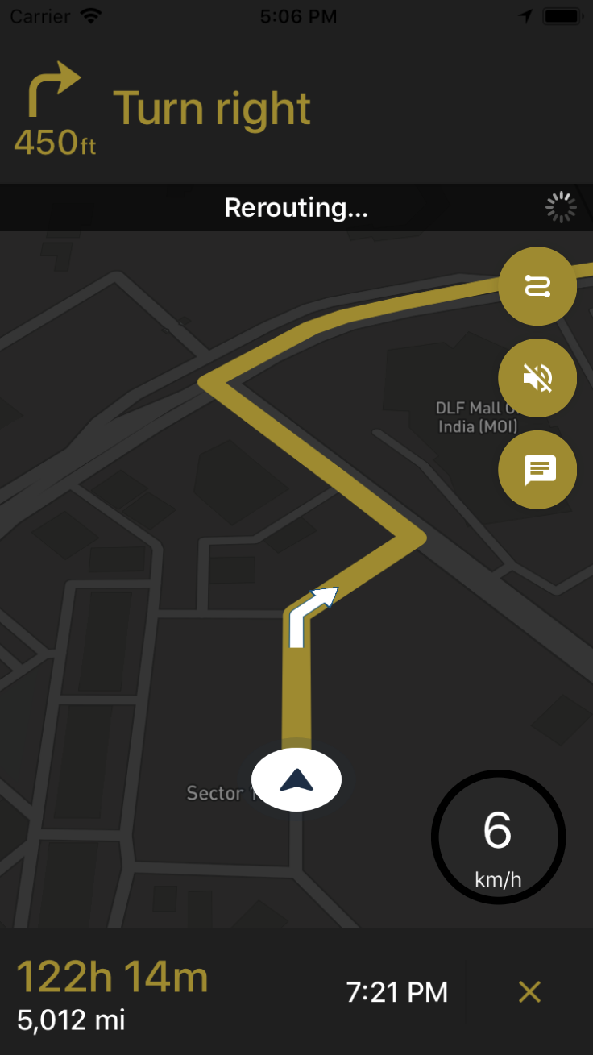

CLASS – NavigationViewController

The screen will appear after clicking on lets go option from Navigation screen, It provides navigation to user from source location to destination location.

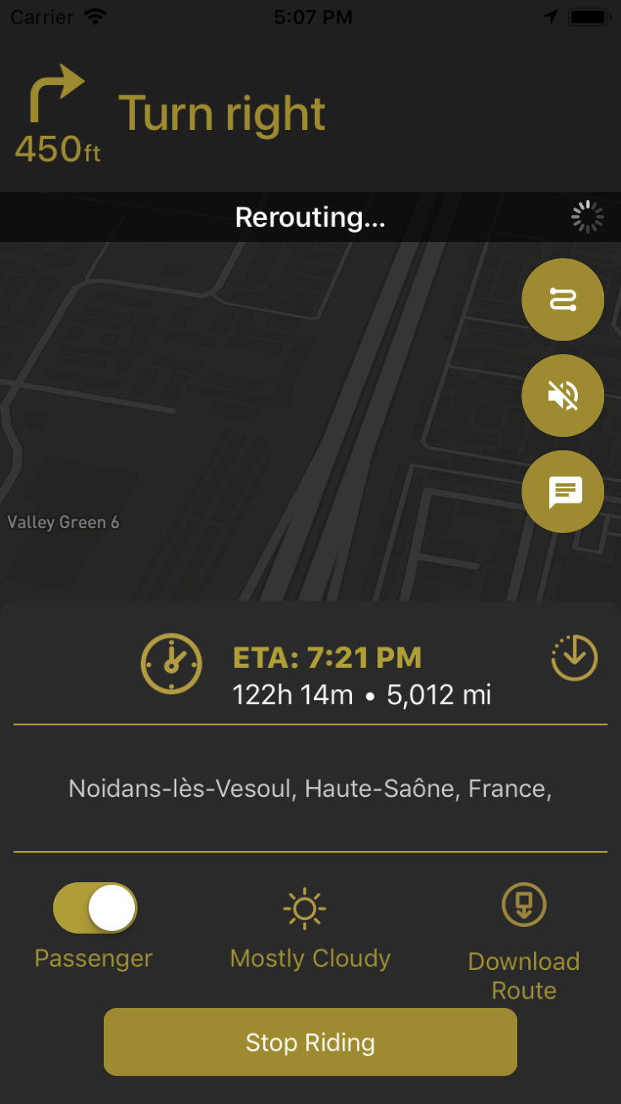

User can see details by clicking on bottom cross button.

Theme can be changed from Mapbox account

For styling Map box we have used CustomDayStyle and CustomNightStyle class

8. Chat Screen

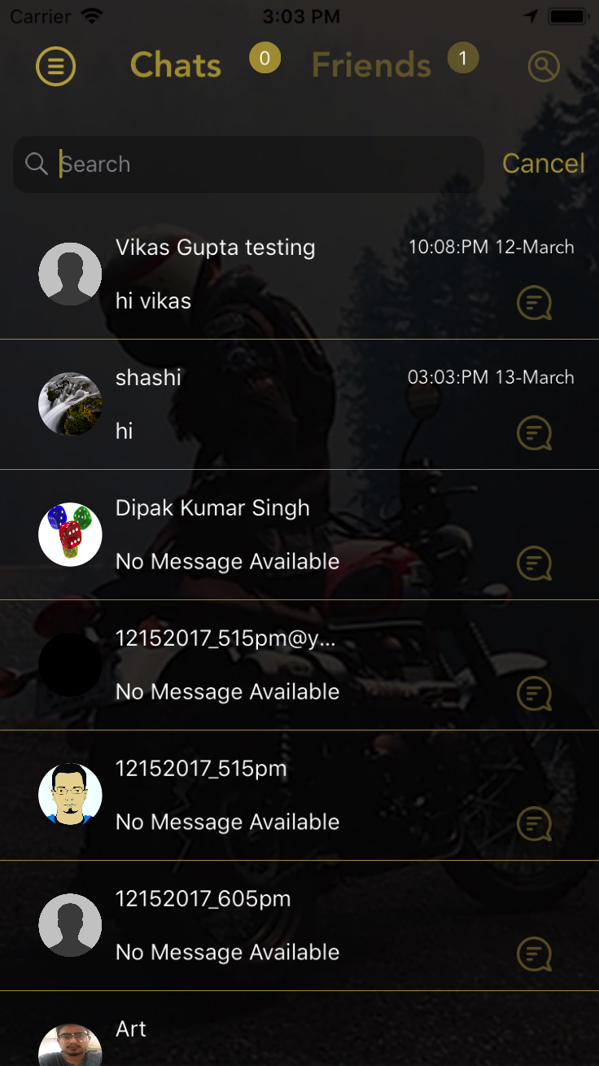

CLASS – ChatListViewController

It displays the chat history, last chat will be displayed in the list.

Top badge on chat will show the number of online users and if a user is online a check mark will be displayed on top of user image icon.

We are using CocoaAsyncSocket pod – For SOCKET CHAT

Chat IP can be set from Constant.swift file

kipChat

8. FRIEND REQUEST SCREEN

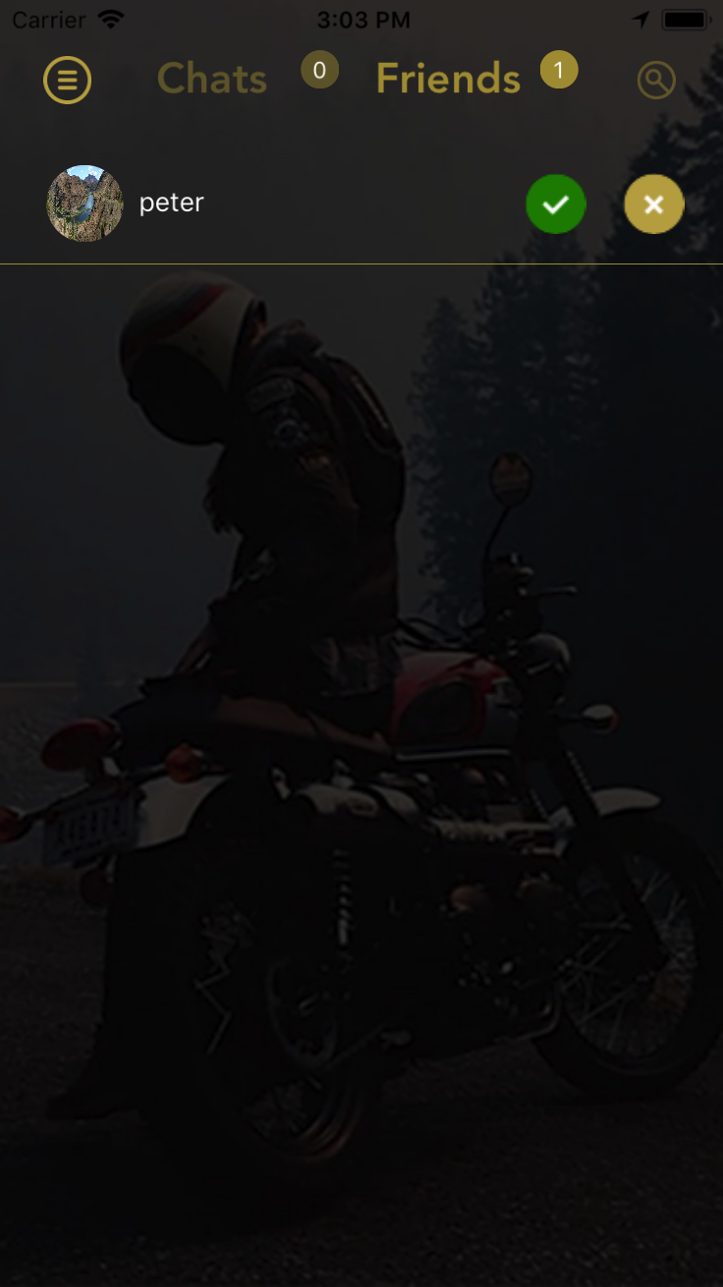

CLASS – ChatListViewController

It displays the list of friends requests user have

We are calling API for Accepting and declining friend request.

8. CHAT SCREEN

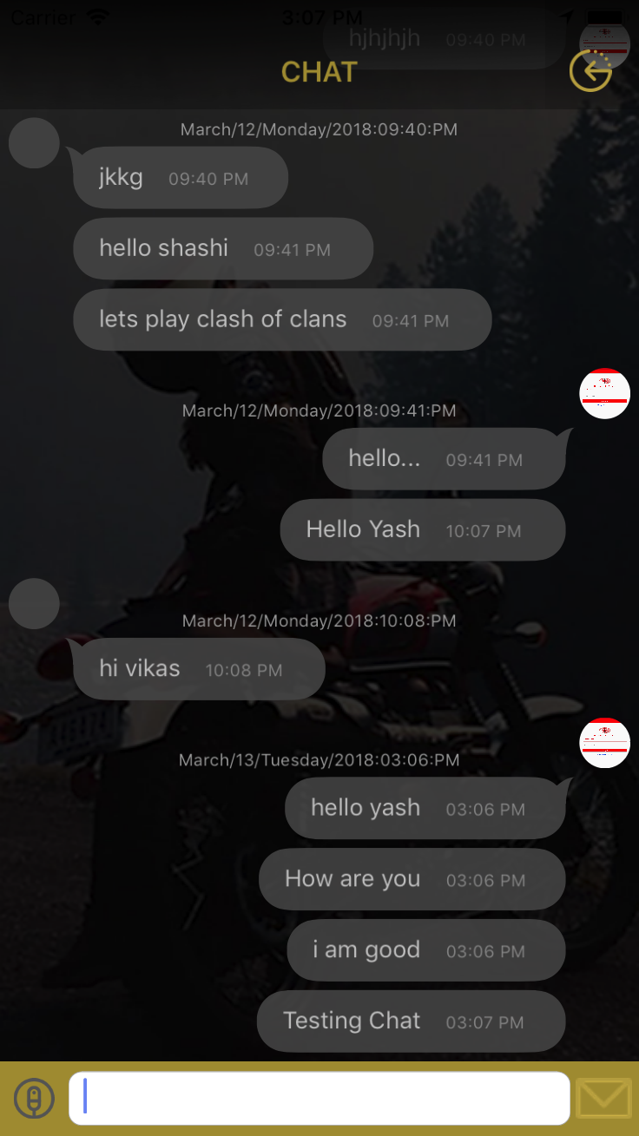

CLASS – ChatTableViewController

It displays the Conversation between users,

User can send and receive chat in this screen, Audio messages can be send by clicking on bottom audio icon.

We have user following pod for chat

pod 'Kingfisher'

pod 'FTIndicator'

pod 'FTPickerView'

pod 'FTImageSize'

8. AUDIO CHAT SCREEN

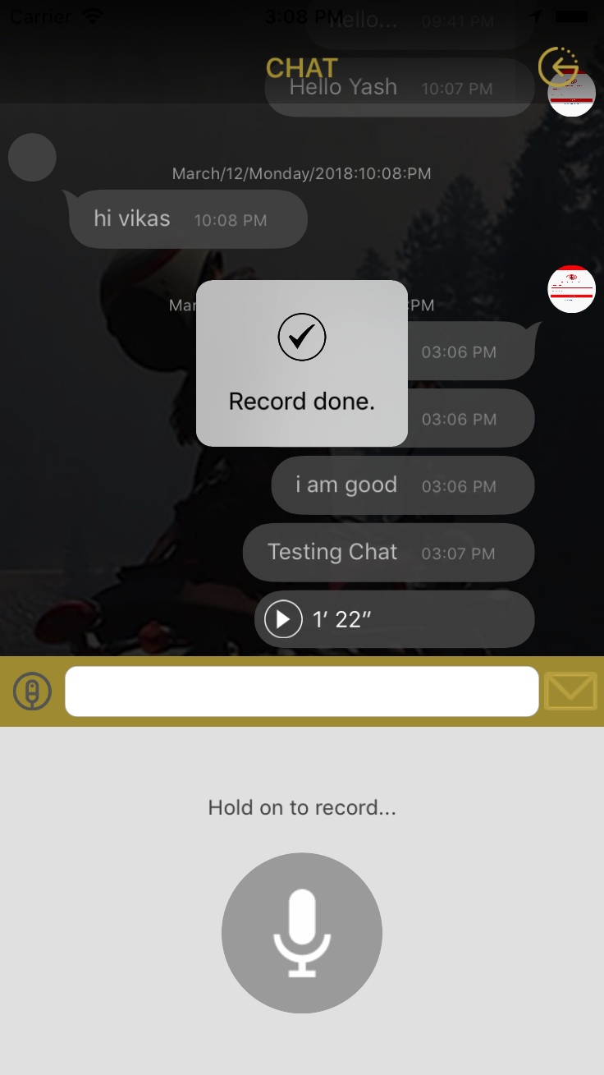

8. CRASH DETECTION SCREEN

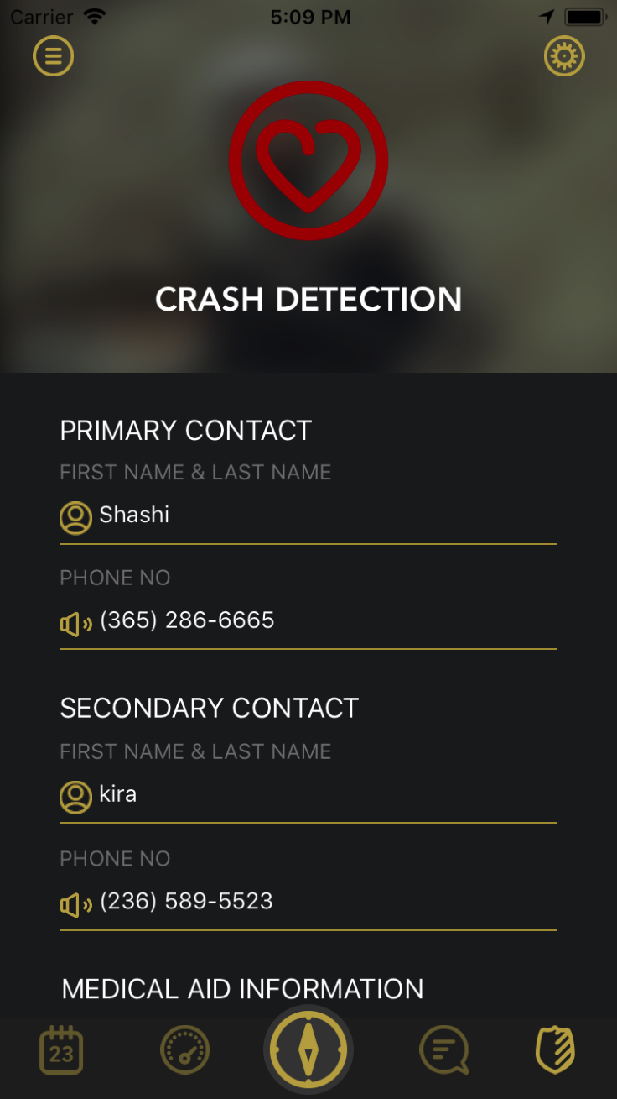

CLASS – CrashDetectionViewController

This screen will open by cliking on shield Icon in tab bar, We are calling API fro saving crash detection information.

**Constants.swift**

-Constants , base url , API request keys, color constants.

**localizable.strings**

-we are maintaining alert messages, placeholders in this file

**WebServiceCall.swift**

-Alamofire GET, POST and DOWNLOAD image methods are written over here

**SERVICE FOLDER**

Service folder consist of services files for various module.

**Model FOLDER**

Model Folder consist of the Model classes for API responses

**POD**

FOR web API calling we are using Alamofire pod

SwiftyJSON- for API response parsing.

CocoaAsyncSocket – For SOCKET CHAT

SwiftLocation – for location update